PARAMETER BASED LANGUAGE AND
Times New Roman, size 18 bold, all caps, centered
SPEECH PACKETIZATION

Three lines space size 16


Logo size
2”x2”
Three lines space size 16

By
One line space size 16

MUHAMMAD Ahmad
(11-ARID-0000)
Two line space size 16

Master of Computer Science
(MCS)
One line space size 16

Barani Institute of Information Technology,
PMAS Arid Agriculture University Rawalpindi.
One line space size 16

Spring/Fall, 2019

PARAMETER BASED LANGUAGE AND
Times New Roman, size 18 bold, all caps, centered
SPEECH PROCESSING
Three lines space size 16

Logo size
2”x2”
Three lines space size 16

A report submitted in partial fulfillment of the
requirements for the degree of
Master of Computer Science
One line space size 16
Submitted By
Muhammad Ahmad
(11-ARID-0000)
One line space size 16

Supervised By
DR. Munir Ahmad
One line space size 16

Barani Institute of Information Technology,
PMAS Arid Agriculture University Rawalpindi.
One line space size 16

Spring/Fall 2019
CERTIFICATE
Times New Roman, size 16, bold, all caps, centered

It is certified that the contents and form of thesis entitled Parameter based Language and speech processing submitted by Muhammad Ahmad have been found satisfactory for the requirement of the degree.

Times New Roman, size 14, bold, all caps, centered

SUPERVISORY COMMITTEE

Times New Roman, size 12, bold, all caps, centered

PROJECT SUPERVISOR: _____________________
Name of Supervisor

REPORT COORDINATER: _____________________
Name of Coordinator
Times New Roman, size 12, bold, Fist cap, centered

WRITEUP COMMITTEE HEAD: _____________________
Name of Head

ACKNOWLEDGEMENT
Times New Roman, size 16, bold, all caps, centered

A candidate may acknowledge contributions to his career and to the dissertation made by any person. Courtesy demands that he acknowledges his advisor and the members of the examination committee. Candidate may not write his name at the end of the acknowledgement.

ABSTRACT
Times New Roman, size 16, bold, all caps, centered, heading level -1
Abstract should be more than 200 words

An analysis is presented of the performance of a serial symbol timing recovery circuit for conventional coherent digital modulated communication systems. The output of the timing circuit is a nearly sinusoidal wave whose zero crossings indicate the appropriate sampling instants for extraction of the data. Assuming that the data pulses entering the timing path are even symmetric, exact analytical expressions for the mean and mean-squared values of the timing wave for the rms phase jitter are derived as a function of various system parameters such as channel by limiting, post filtering, delay element, and power spectral density of noise. Numerical results, also checked by computer simulations, show that considerable improvement can be obtained in jitter performance in addition to having the advantages of lower cost and simpler hardware implementation over other techniques.
ABBREVIATION & SYMBOLS
Times New Roman, size 16, bold, all caps, centered,
Symbol/Abbreviation Term
a ---------------------------------------------------------------------------- Area
c ---------------------------------------------------------------------- Cohesion
E ----------------------------------------------------------- Young’s modulus
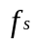 ----------------------------------------------------------------- Skin friction
g ----------------------------------------------- Acceleration due to gravity
k ------------------------------------------------ Coefficient of permeability
psi ------------------------------------------------ pounds per square inch
S_{r} --------------------------------------------------- Degree of saturation
t ---------------------------------------------------------------------------- Time
tsf ----------------------------------------------------- Tons per square foot
 ---------------------------------------------------------------- Shape factor
------------------------------------------------------------------------ Density
------------------------------------------------------------- Angle of friction
----------------------------------------------------------------- Wave length
 -------------------------------------------------------------- Poisson’s ratio
Alphabetically arranged ascending order
Greek symbols arranged after roman symbols
TABLE OF CONTENTS
Contents .. Page No.
Times New Roman, size 16, bold, all caps, centered,
certificate iii
ACKNOWLEDGEMENT iv
ABSTRACT v
aBBREVIATION & SYMBOLS vi
TABLE OF CONTENTS vii
LIST OF TABLES viii
LIST OF FIGURES ix
CHAPTER 1- INTRODUCTION 01
1.1 INTRODUCTORY BACKGROUND 01
1.2 PROBLEM STATEMENT 02
1.3 OBJECTIVES 03
1.4 SCOPE 04
1.5 REPORT ORGANIZATION 10
CHAPTER 2- Background 11
2.1 RELATED PROJECTS AND RESEACH ARTICLES 11
2.1.1 Screen Shots of old Related Projects 12
2.2 Related Software in Market 13
CHAPTER 3- conceptual design 15
3.1 REQUIREMENT ELICITATION (SOURCES OF REQUIREMENTS) 15
3.2 REQUIREMENT SPECIFICATION 16
3.2.1 Functional Requirements………………………………………………...17
3.2.2 Non-functional Requirements…………………………… ……………...18
3.2.3 Domain Requirements …………………………………………………18
3.3 REQUIREMENT MODELING 19
3.3.1 Dataflow diagram or Usecase diagram …………...……...……………...20
3.4 REQUIREMENT VALIDATION (SOURCES THOSE VALIDATED THE REQUIREMENTS) 21
3.5 DATABASE DESIGN 23
3.5.1 Entity Relatonship Diagram……………………………………………...24
3.6 LOGICAL DESIGN 25
3.6.1 Conceptual Diagram ……………...………………………………...…...26

chapter 4- implementation 27
4.1 TOOLS & TECHNOLOGIES 28
4.2 ALGORITHMS (IF THEY EXIST) AND SOME SCREEN SHOTS 29
4.3 CODING 30
4.4 PROJECT SCREEN SHOTS...……………………… …………………….......31
CHAPTER 5- conclusion 32
5.1 CONCLUDING REMARKS 33
5.2 FUTURE DIRECTIONS 34
5.3 LIMITATIONS 35
Biblography 36

**generate automatically using MS Word**

LIST OF TABLES

Table Page No.
2.1 Speech Data 15
3.1 Projected Score 20

**generate automatically using MS Word**

LIST OF FIGURES

Figure Page No.
2.1 Existing System 15
3.1 ERD 20
4.1 Screen Shot 1 25

**generate automatically using MS Word**

CHAPTER 3
CONCEPTUAL DESIGN
Double line space in font size 16
Times New Roman, size 16, bold, all caps, left align

Strength and deformation characteristics play an important role in the design of structures in rock. A number of techniques which may be grouped under static and dynamic methods are available for the determination of these parameters (table 4.1). The results of correspondence between strength and dynamic modulus of elasticity are reported elsewhere (Kazi, 1983; King, 1983).
Times New Roman Font 12 Normal Paragraph with indent on first line. Justified and 1.5 spaced lines
Double line space in font size 12

3.1 DYNAMIC YOUNG’S MODULUS
Theoretical considerations presented by Picket and Avedissian about the seismic pulse method are given in (Picket, 1945), (Avedisian, 1972). In this method, as illustrated in Fig. 4.1, the travel time of a pulse generated at one end of the specimen is measured on its arrival at the receiving end. Depending on the type of wave generated, it may be shown, from the theory of elastic wave propagation, that
Heading Level 2: Arabic numeral followed by dot and 2 spaces. Then title with first letter cap: Times New Roman Font 16 Bold left aligned
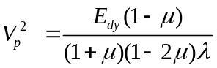
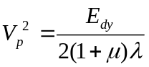
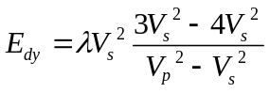
Where,
V_{p} = velocity of compression wave,
V_{S} = Velocity of shear wave,
µ = Poisson,s ratio, and
= density.

Table 3.1: Stress Concentration around the trapezoidal section of the tunnel
 | Stress Concentration 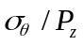
 | K = 0.0 |  |  | K = 0.333
 | R | S | F | R | S | F
1 | -0.27 | 2.27 | -0.83 | -0.29 | 1.93 | -0.56
2 | -0.67 | 2.05 | -0.83 | -0.24 | 1.9 | -0.56
2.5 | -1.4 | 1.96 | -1.62 | -0.87 | 1.78 | -1.35
3 | -1.57 | 2.01 | -1.7 | -0.95 | 1.82 | -1.58
Homo- geneous  media | -0.83 | 1.87 | -0.97 | -0.307 | 1.58 | -0.476

**Provide Explanation for the tables **

Table 3.2: Stress Concentration around the arched roof of the tunnel
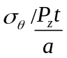 | Stress Concentration
 | K = 0.0 |  |  | K = 0.333
 | R | S | F | R | S | F
1 | -0.75 | 3.03 | -0.95 | 0.01 | 2.95 | -0.53
2 | -0.45 | 2.89 | -0.87 | 2.02 | 2.47 | -0.51
2.5 | -1.35 | 2.82 | -1.52 | 0.006 | 2.42 | -1.12
3 | -1.52 | 2.86 | -1.72 | 0.1 | 2.43 | -1.28
Homo- geneous  media | -0.91 | 2.72 | -0.984 | 0.008 | 2.386 | -0.49
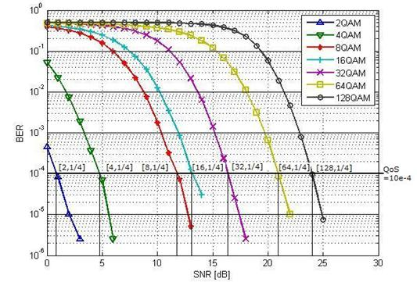
Figure 3.1: Relationship between SNR and BER for various modulation schemes

**Proper explanation for all figures (including graphs and screen shots) and tables must be provided. Moreover, citations must be done properly, if the data provided is taken from some other source. **

3.2 DATA FLOW MODEL
Data flow diagram (DFD) is a graphical representation that depicts information flow and the transforms that are applied as data moves from input to output. Data flow diagram is also known as bubble chart and data flow graph.
3.2.1 Components of DFD
DFD comprises of four notations. Each notation is explained below.
- Process
A process represents a transform that is applied to data and changes it in some way. A process comprises a set of steps that transforms input into output. The processes of DFD identify what different work has to be done in the system. A process is represented by a circle or rounded rectangle as shown below.

Figure 3.2: Representation of a DFD process
naming convention:
A process is denoted by a circle or rounded rectangle. Process name should begin with a verb and end with a noun.
Example:
Process Sale, Register Student, Update inventory etc.
- Entity
External agent is also called an entity. An entity is a system element (e.g., hardware, a person or another program) or another system that provides information to be transformation by the software. Entities of DFD are outside the boundary of software system. An entity is represented by a square or rectangle as shown below.

Figure 3.3: Representation of a DFD Entity
naming convention:
An entity is denoted by a noun and written in capital letters.
Example:
Student, Customer, Store house etc.

- Data Store
Data store represents stored information (either temporary or permanently) that is used by software. It indicates the data which is being stored for later retrieval. Data store is used to provide input to the process and outputs of the processes may be going into these data stores. Data stores are represented by following three notations.

Figure 3.4: Representation of a DFD data store
naming convention:
The name of data store must represent its contents.
Example:
Student Information File, Customer Record, Sales Register etc.

- Data Flow
Data flow represents one or more data items (or data objects). It indicates the flow of data in a data flow diagram. It is represented by labeled arrow as shown below.
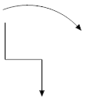
Figure 3.5: Representation of a DFD data flow
naming convention:
The name of data flow must represent its contents.
Example:
Student details, Customer Profile, login+password etc.

3.3 INVALID LINKS IN DFD
The DFD should not have the following links
- Entity to Entity
- Entity to data store
Since entity is an external unit its links with data stores and other entities are outside the scope of software system to be developed. Therefore the given links are invalid.

3.4 DFD LEVELS AND PROCESS NUMBERING
DFD is organized in form of levels. Each level adds more details to previous one. DFD usually begins with drawing a context diagram or fundamental system model or level 0, a simple representation of the whole system. Level 0 has represents the entire software system as a single bubble with input and output data indicated by incoming and outgoing arrows respectively. To elaborate further, DFD is drilled down to a level 1 diagram with additional information about the major functions of the system. This could continue to evolve to become a level 2 diagram when further analysis is required. Progression to level 3, 4 and so on, is possible but anything beyond level 3 is not very common.
The processes at each level are identified by unique numbers. The numbering of process at each level is shown in figure below.
3.4.1 Level 0 Diagram
Level 0 represents the entire software system as a single bubble with input and output data indicated by incoming and outgoing arrows respectively.
- The number 0 is assigned the single process
- The process naming convention is not followed
- There are no data stores
3.4.2 Level 1 Diagram
- Shows all the processes that comprise a single process on the level 0 diagram
- Shows how information moves from and to each of the processes
- Process numbers starts with 1, 2, 3 and so on.
- Level 1 has data stores
3.4.3 Level 2 Diagram
- Shows all processes that comprise a single process on the level 1 diagram
- Shows how information moves from and to each of these processes
- Level 2 diagrams may not be needed for all level 1 processes
- Correctly number each process of level 2. For example if process 1 is extended to level 2 then number at process of level 2 by prefixing 1 i.e 1.1, 1.2, 1.3, …

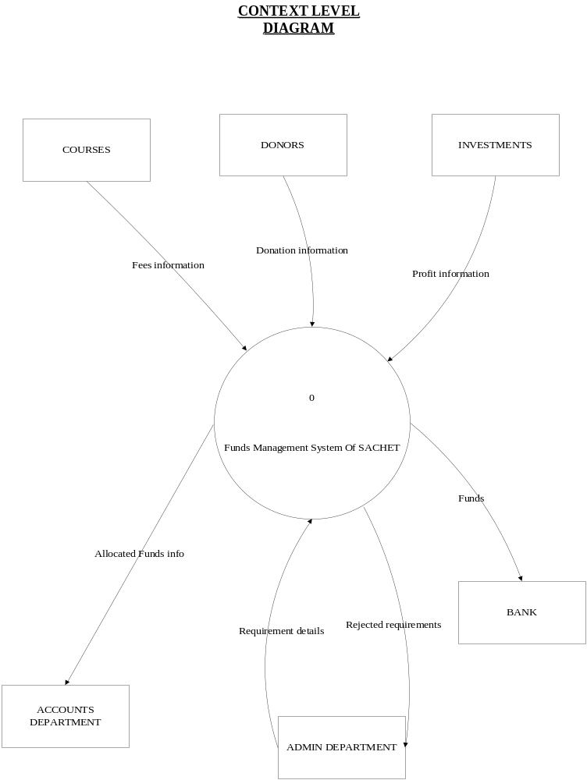
Figure 3.6: Conceptual Design Diagram

Approved By: Teacher Name
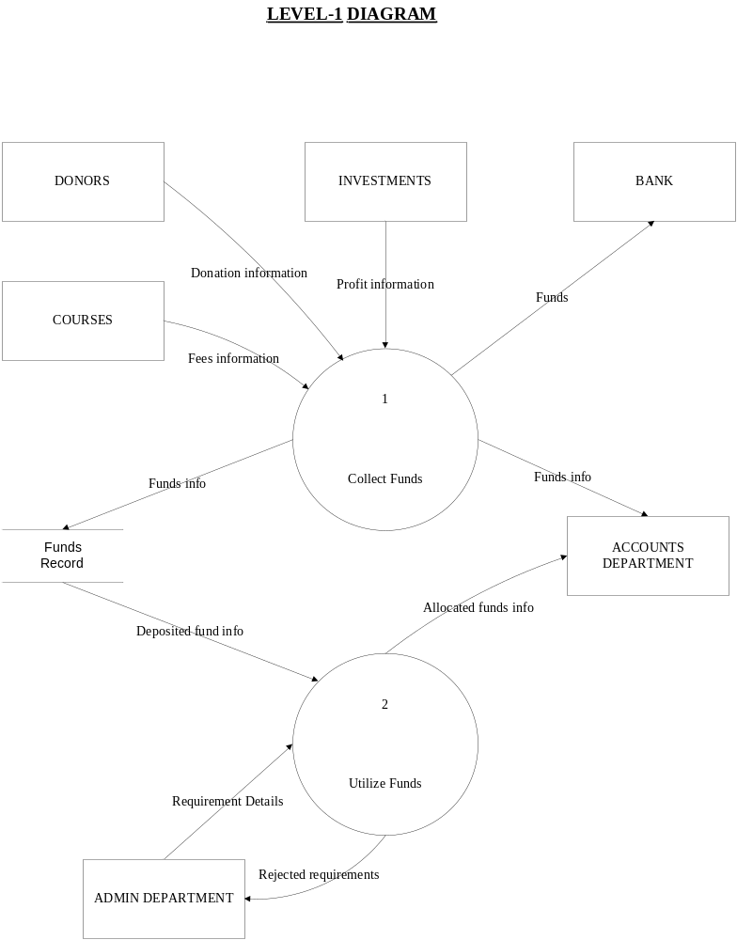
Figure 3.7: Level-1 Diagram
**students must provide proper explanation of all DFD levels**

Approved By: Teacher Name

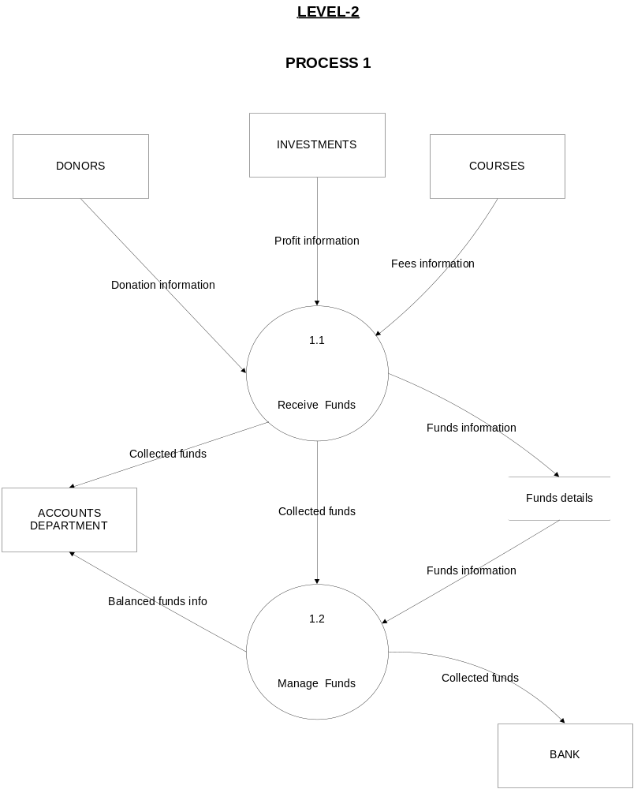
Figure 3.8: Level-2 (Process-1) Diagram

Approved By: Teacher Name

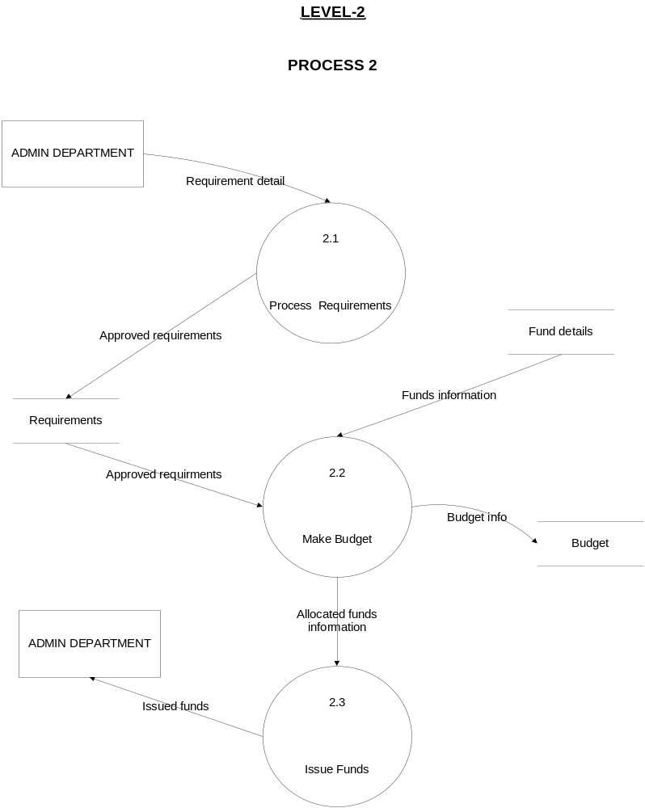

Figure 3.9 Level-2 (Process-2) Diagram

Approved By: Teacher Name

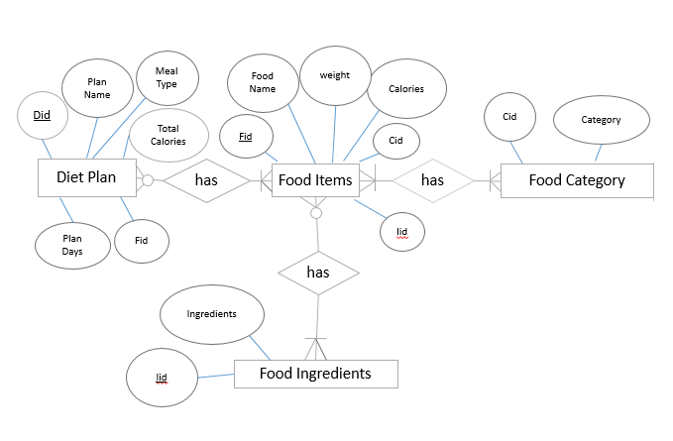
Figure 3.10 Entity Relationship Diagram

Approved By: Teacher Name
Bibliography
Author name(s) ,last name first. All caps
Journal as a ref
CARRIER, A. (1987) Sequential steps in project execution. International Journal of Project Management, Vol. 5, No. 1, pp. 25-28.

CHLINGARIAN, V.V., REIKE, H.H. and KAZI, A. (1994) Chemistry of pore water. In: W. H. Fertl, R.E. Chapman and R.F. Holtz (editors) Studies in Abnormal Pressures, Elsevier, Amsterdam, pp. 107-153
Handbook as a ref
Technical report as a ref
DEERE, D.U., and MILLER, R.P. (1966). Engineering classification and inde: properties of intact rocks. Technical Report No. AFWL-TR 65-116, Ai Force Weapons Laboratory, New Mexico.

GUIDO, V.A., CHANG, D.K. and SWEENEY, M.A. (1986) Comparison of geogrid and geotextile reinforced earth slabs. Canadian Geotechnical Journal, Vol. 23, pp. 435-440.

KAZI, A. (1968) Aspects of the engineering geology of laminated glacial take clays. Ph. D. thesis, University of London.
Thesis as a ref

KAZI, A (1975) Quantitative fabric analysis of Drammen Clay using X-ray diffraction technique. Journal of sedimentary Petrology. Vol. 45, No. 4, pp. 883-890.

KAZI, A. (1995) An overview of indicator organisms to assess the safety of drinking water supplies. DMMR Technical Report No. MAK-TR-95-1, Saudi Deputy Ministry of Mineral Resources, Jeddah.
Proceedings as ref
KAZI, A. and Sen, Z. (1985) volumetric RQD: An index-of rock quality. Proceeding of the International Symposium on Fundamentals of Rock Joints, Bjorkliden, Sweden, pp. 95-102.

MEYERHOD, G.G. (1948) An investigation of the bearing capacity of shallow footings on dry sand. Proceedings of the 2nd international Conference on Soil Mechanics and Foundation Engineering, Rotterdam, Netherlands, Vol. 1 , pp. 237-243.

SABTAN, A. A. (1988) Determination of longitudinal and lateral sediment distribution in reservoirs. Ph. D. dissertation, South Dakota School of Mines. Rapid City.

TERZAGHI, K. and PECK, R.B. (1967) Soil Mechanics in Engineering Practice, 2nd ed;, John Wiley & Sons New York, 729 pp.
Books as a ref

THOMAS, C;, BEGG, C. and STRACHAN, A. (1997) database Systems, Addison Wesley Longman Limited, Essex, 939 pp.

QURESHI, S. (2004) Venus makes rare transit across Sun. Dawn, June 9, p.1.
Newspaper as a ref

GOVERNMENT OF PAKISTAN (2002) Textile Production of 2001. A report of statistical Bureau, GOP/Tx/R2-2002, Islamabad. Pp. 23.
Govt. Report as a ref

www.isra.edu.pk (2004) Admission of foreign nationals to Faculty of Medicine and Allied Medical Sciences: (Accessed 2007, June 19)
URL as a ref

RAHMAN, A., QURESHI I.M., NASEEM M.T., MUZAFFAR M.Z. et al. (2014) Dynamic Resource Allocation in OFDM Systems using DE and FRBS. Journal of Intelligent and Fuzzy Systems. Vol. 1, No. 26, pp. 2035-2046.
(Year) follows the author name(s) followed by paper title with only the first letter of the first word cap and dot at the end

